Software Engineering
Project Progress Report – Phase I
Project Title: Prompt Injection Detection
Students Details
SAP ID | Roll Number | Name of the Student
70102400069 | K017 | Shripad Jadhav
70102400071 | K032 | Debayan Lahiry
70102400036 | K049 | Sarah Samel

Abstract
Prompt injection is one of the major security vulnerabilities for Large Language Models (LLMs). An adversary can craft prompts and induce the language model to behave contrary to its instruction or ignore its original intended purpose. This project will build a detection system for prompt injection attack with DataSentinel, an algorithm that leverages game theoretic optimization to enhance prompt injection detection against adaptive attacks. In this detection system, user prompts will be analyzed, classified as either benign or malicious prompts. To make the system more robust, this project also considers other adversarial/obfuscated prompts that can circumvent standard prompt injection detection systems. Evaluations of the proposed system are done using publicly available prompt injection benchmarks and some performance metrics like accuracy, precision, recall, and F1-score.

Introduction
Large Language Models (LLMs) are now widely deployed in such areas as chatbots, virtual assistants, information retrieval engines, and other AI-based applications that are capable of interacting with external software or data. Nevertheless, the possibility for LLMs to accept natural language instructions poses additional security threats in the form of a variety of prompt injection attacks. In such an attack, the attacker constructs a malicious prompt in order to attempt to overwrite the original instructions of the LLM in question, manipulate its operation, access sensitive data, or execute some other actions. With LLM-based systems being implemented more and more frequently in practical applications, it is essential to devise a way to prevent or detect such attacks, as it is a relevant AI security issue.
The goal of the project is to design a system that can reliably detect the malicious prompt before it can affect the LLM and its components. The current project is based on DataSentinel, which is a game-theoretical method intended to help in improving prompt injection detection in adaptive scenarios. The proposed system will analyze the incoming prompts, and distinguish between the malicious and benign ones, as well as deal with any possible adversarial and obfuscated versions of the latter that are hard for the ordinary detectors to recognize. The primary goal is to enhance the prompt injection detection robustness by testing the system on publicly available benchmark data. To assess performance, accuracy, precision, recall and F1-scores will be used.

Literature Review Summary
It is apparent from the literature review that prompt injection has evolved from simple instruction-based attacks to the larger problem of LLM security issues that involve adaptation, indirectness, adversarialness, and agent-based attacks. Recent studies like Formalizing and Benchmarking Prompt Injection Attacks and Defenses introduced systematic threat models and benchmarks, while studies like Neural Exec, JudgeDeceiver, and AutoHijacker explored automated and optimization-based methods of attack generation. Recent studies like InjecAgent, AgentDojo, and BIPIA moved focus to indirect prompt injection in LLM agents, RAG systems, and integrated tools.
There is a great focus on defense and detection mechanisms in recent literature. They include structured prompts such as StruQ, instruction hierarchy using Instructional Segment Embedding, preference optimization using SecAlign, defensive tokens, and guardrails like PIGuard/NotInject and PromptShield. All of them try to prevent any malicious instructions from being followed or detect them in advance. Yet, most of them need the fine-tuning of the model, model architecture, or information about the attack pattern.Attack generation: Several papers focus on developing stronger prompt-injection attacks, including optimization-based, adversarial, topic-transition, pseudo-conversation, and automated attacks.
- Benchmarking: Publications like BIPIA, AgentDojo, and InjecAgent allow for testing prompt-injection vulnerabilities in structured datasets and environments.
- Indirect prompt injection: The focus of most recent works is on malicious instructions embedded in external sources, such as webpages, emails, documents, and output of tools.
- Security of agents: A considerable share of recent work is aimed at LLM agents, where prompt injection may affect the agent’s decision-making process or the tools used by it.
- Detection approaches: The mentioned Vigil, PromptShield, PIGuard, and DataSentinel are more focused on the task of detection or filtering of malicious prompts.
- Adaptive attacks: In particular, DataSentinel is noteworthy as it employs game-theoretic minimax optimization in training a detector against adaptive attacks on it.
- Modification of the model: StruQ, SecAlign, Instructional Segment Embedding, and DefensiveTokens approach the problem by modifying or fine-tuning the LLM itself.
- Limited robustness: Most approaches are tested against specific attack scenarios or datasets, hence their effectiveness against other, potentially unknown, obfuscated or newly invented attacks might be different.
- Computational requirements: Several recent approaches require fine-tuning large models, access to model activations, or specialized optimization, which can make practical deployment more difficult.
- False positives: Guardrail-based approaches such as PIGuard specifically address the problem of over-defense, where legitimate prompts may incorrectly be classified as malicious.
From the literature, one thing that becomes clear is that there is no one solution that solves the issue of all types of prompt injection attacks. The approaches that have been developed till date usually focus on either a certain attack method or an agent environment or a model architecture. From the shortcomings observed, our proposed research can explore avenues for making the detector more robust.

Key Ideas from Literature Review
• Prompt injection represents a significant security vulnerability for LLM-powered apps, especially those that interact with other software and data.
• State-of-the-art methods in prompt injection go beyond simple attacks and include adaptive, indirect, adversarial, and automated prompt injection attacks.
• Development of benchmark datasets and test environments like BIPIA, AgentDojo, and InjecAgent enables the systematic assessment of prompt injection defense techniques.
• Multiple papers apply LLMs, fine-tuning, adversarial training, optimization, and guardrail methods for prompt detection or prevention of malicious prompts.
• DataSentinel concentrates on adaptive prompt attacks and uses game-theoretical minimax optimization for prompt injection detection improvement.
• Current solutions have limitations including high computation costs, dependency on a particular dataset or attack type, and inability to detect novel or camouflaged attacks.
• The reviewed literature demonstrates the necessity of advanced prompt injection detection techniques that can recognize new patterns and generate few false alarms.

Base Paper https://ieeexplore.ieee.org/document/11023476

Limitations of the Base Paper
It is clear that DataSentinel offers an effective solution for identifying prompt injections because it uses game-theoretic optimization for making their system robust against adaptive prompt injection attacks. At the same time, this solution implies fine-tuning of LLM and minimax optimization which may demand high computational costs. In addition, the evaluation of this system was done using some benchmarked data sets and attacks which means that the efficiency of it in terms of prompt injections from other sources should be examined.
Key limitations:
- High computational requirements due to LLM fine-tuning and game-theoretic optimization.
- Limited evaluation against unseen attack patterns, particularly highly obfuscated injections.
- Dependence on benchmark datasets may not represent all real-world prompt injection scenarios.
- Complex implementation compared with simpler ML-based detection approaches.
- Potential generalization issues when applied to different LLMs, applications, or agent environments.
- The approach can be further improved by adding adversarial/obfuscated prompt augmentation and testing robustness on a broader range of attacks.

Expected Outcomes
The goal of this project is to develop a way to improve the approach for detecting prompt injection attacks, called DataSentinel. In order to make the new approach better, it should become more resistant to various prompt patterns that can potentially bypass the original detection mechanism. For this purpose, the current framework of the approach called DataSentinel will be used as a baseline and an extra layer of adversarial prompt preprocessing will be added.Add adversarial prompt augmentation to create variations of existing injection attacks.
- Include obfuscated prompts, such as altered characters, spacing, punctuation, and instruction splitting.
- Improve detection of previously unseen prompt injection patterns.
- Compare the original DataSentinel with the improved DataSentinel.
- Evaluate using accuracy, precision, recall, F1-score, and false-positive rate.
- Aim to improve robustness and generalization without significantly increasing false positives.
- Develop a more practical detection pipeline that can be evaluated on publicly available prompt-injection datasets.

Project Functionalities
The proposed system will function as a prompt injection detection and classification system based on the DataSentinel approach. It will analyze incoming prompts, identify potentially malicious instructions, and improve detection by testing against adversarial and obfuscated variations. The system will provide a clear classification and performance analysis to evaluate the effectiveness of the proposed improvements.
Key functionalities:
- Prompt Input: Accept user prompts as input for security analysis.
- Text Preprocessing: Clean and normalize prompts before detection.
- Adversarial Prompt Generation: Generate modified and obfuscated variations of injection prompts.
- Prompt Injection Detection: Use the DataSentinel-based detector to identify malicious prompts.
- Classification: Classify prompts as Benign or Prompt Injection.
- Robustness Testing: Test the detector against unseen and adversarial prompt patterns.
- Performance Evaluation: Calculate accuracy, precision, recall, F1-score, and false-positive rate.
- Comparison: Compare the original DataSentinel approach with the proposed improved approach.
- Result Visualization: Display detection results and performance metrics using tables/graphs.

Project Module
- Prompt Input Module
Accepts user prompts and prepares them for analysis by the detection system.
- Data Collection & Dataset Module
Loads publicly available prompt-injection datasets containing benign and malicious prompts for training, testing, and evaluation.
- Preprocessing Module
Cleans and normalizes the input text by handling unnecessary spaces, punctuation, special characters, Unicode variations, and other text irregularities.
- Adversarial Prompt Augmentation Module
Generates variations of prompt-injection attacks, such as obfuscated text, character substitutions, altered spacing, and instruction manipulation, to improve detector robustness.
- DataSentinel Detection Module
Implements the DataSentinel-based detection approach as the baseline for identifying prompt injection attacks.
- Improved Detection Module
Applies the proposed modifications to the baseline system, particularly the adversarial augmentation/preprocessing techniques, to improve detection of difficult and unseen attacks.
- Prompt Classification Module
Classifies each prompt into categories such as Benign or Prompt Injection based on the detector's output.
- Performance Evaluation Module
Measures the system using Accuracy, Precision, Recall, F1-score, and False Positive Rate and compares the original and improved approaches.
- Visualization & Reporting Module
Displays results using confusion matrices, graphs, tables, and performance comparisons to clearly demonstrate the effectiveness of the proposed system.

Methodology Diagram
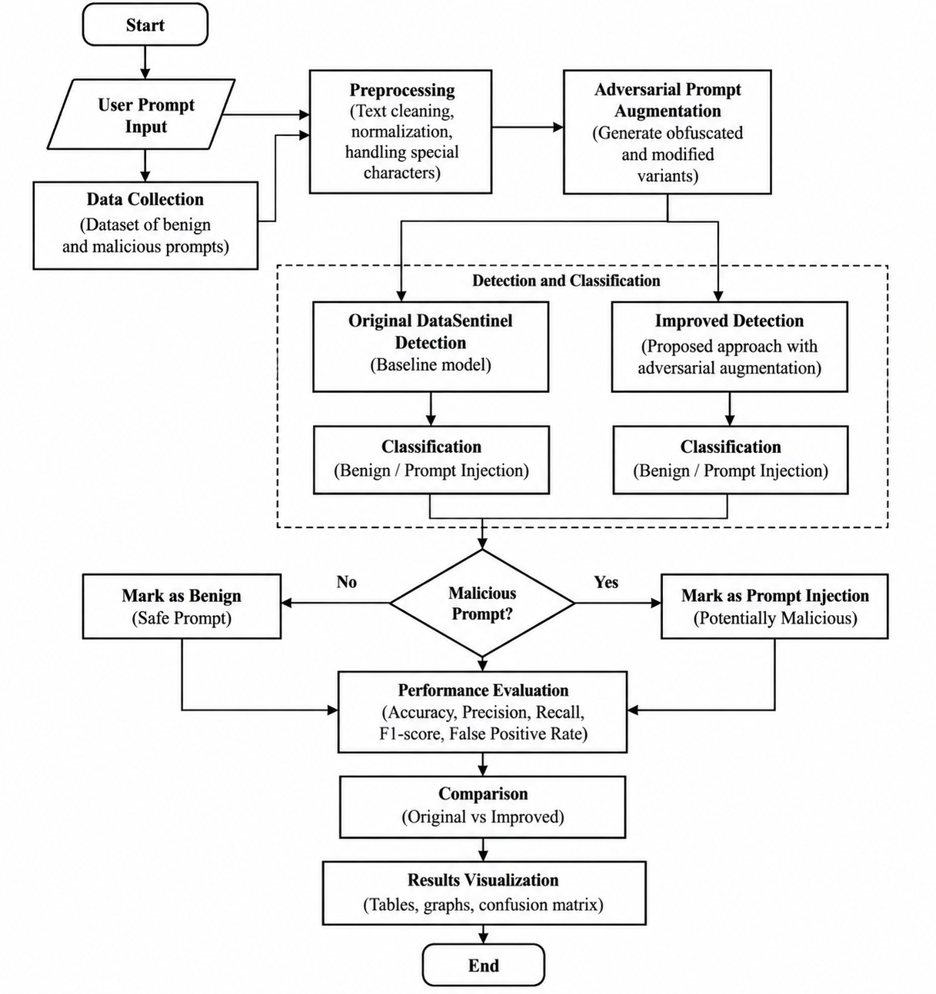
References
[1] Y. Liu, Y. Jia, R. Geng, J. Jia, and N. Z. Gong, “Formalizing and benchmarking prompt injection attacks and defenses,” in Proc. 33rd USENIX Security Symp., 2024, pp. 1831–1847.
[2] J. Shi, Z. Yuan, Y. Liu, Y. Huang, P. Zhou, L. Sun, and N. Z. Gong, “Optimization-based prompt injection attack to LLM-as-a-judge,” in Proc. 2024 ACM SIGSAC Conf. Comput. Commun. Security (CCS), 2024, pp. 660–674.
[3] D. Pasquini, M. Strohmeier, and C. Troncoso, “Neural Exec: Learning (and learning from) execution triggers for prompt injection attacks,” in Proc. 2024 Workshop on Artificial Intelligence and Security (AISec), 2024, pp. 89–100, doi: 10.1145/3689932.3694764.
[4] Q. Zhan, Z. Liang, Z. Ying, and D. Kang, “InjecAgent: Benchmarking indirect prompt injections in tool-integrated large language model agents,” in Findings of the Association for Computational Linguistics: ACL 2024, 2024, pp. 10471–10506, doi: 10.18653/v1/2024.findings-acl.624.
[5] E. Debenedetti, J. Zhang, M. Balunović, L. Beurer-Kellner, M. Fischer, and F. Tramèr, “AgentDojo: A dynamic environment to evaluate prompt injection attacks and defenses for LLM agents,” in Advances in Neural Information Processing Systems (NeurIPS), vol. 37, 2024, pp. 82895–82920.
[6] C. Sanin, “An adversarial machine learning approach on securing large language model with Vigil, an open-source initiative,” Procedia Computer Science, vol. 246, pp. 686–695, 2024, doi: 10.1016/j.procs.2024.09.486.
[7] J. Yi, Y. Xie, B. Zhu, E. Kiciman, G. Sun, X. Xie, and F. Wu, “Benchmarking and defending against indirect prompt injection attacks on large language models,” in Proc. 31st ACM SIGKDD Conf. Knowledge Discovery and Data Mining (KDD), 2025, pp. 1809–1820, doi: 10.1145/3690624.3709179.
[8] S. Chen, J. Piet, C. Sitawarin, and D. Wagner, “StruQ: Defending against prompt injection with structured queries,” in Proc. 34th USENIX Security Symp., 2025, pp. 2383–2400.
[9] T. Wu, S. Zhang, K. Song, S. Xu, S. Zhao, R. Agrawal, S. R. Indurthi, C. Xiang, P. Mittal, and W. Zhou, “Instructional segment embedding: Improving LLM safety with instruction hierarchy,” in Proc. 13th Int. Conf. Learning Representations (ICLR), 2025, pp. 78078–78108.
[10] S. Chen, A. Zharmagambetov, S. Mahloujifar, K. Chaudhuri, D. Wagner, and C. Guo, “SecAlign: Defending against prompt injection with preference optimization,” in Proc. 2025 ACM SIGSAC Conf. Comput. Commun. Security (CCS), 2025, pp. 2833–2847, doi: 10.1145/3719027.3744836.
[11] S. Chen, Y. Wang, N. Carlini, C. Sitawarin, and D. Wagner, “Defending against prompt injection with a few DefensiveTokens,” in Proc. 18th ACM Workshop on Artificial Intelligence and Security (AISec), 2025, pp. 242–252, doi: 10.1145/3733799.3762982.
[12] H. Li, X. Liu, N. Zhang, and C. Xiao, “PIGuard: Prompt injection guardrail via mitigating overdefense for free,” in Proc. 63rd Annu. Meeting Association for Computational Linguistics (ACL), vol. 1, 2025, pp. 30420–30437, doi: 10.18653/v1/2025.acl-long.1468.
[13] D. Jacob, H. Alzahrani, Z. Hu, B. Alomair, and D. Wagner, “PromptShield: Deployable detection for prompt injection attacks,” in Proc. 15th ACM Conf. Data and Application Security and Privacy (CODASPY), 2025, doi: 10.1145/3714393.3726501.
[14] Y. Liu, Y. Jia, J. Jia, D. Song, and N. Z. Gong, “DataSentinel: A game-theoretic detection of prompt injection attacks,” in Proc. 46th IEEE Symp. Security and Privacy (SP), 2025, pp. 2190–2208, doi: 10.1109/SP61157.2025.00250.
[15] X. Liu, S. Jha, P. McDaniel, B. Li, and C. Xiao, “AutoHijacker: Automatic indirect prompt injection against black-box LLM agents,” in Proc. Int. Conf. Learning Representations (ICLR), 2025.

